

CMPSC 463 (Spring 2026)
Dsgn Analysis Algs

Project-1

Aram Asdourian

Instructor: Janghoon Yang

Submitted On: 3/12/2026

Table Of Contents
# | Section | Page
1 | Project Overview | 3
2 | Installation and Usage Instructions | 3
3 | Code Structure Explanation | 5
4 | Algorithm Description | 6
5 | Toy Example Verification | 7
6 | Dataset Description | 8
7 | Execution Results | 8
8 | Discussion and Conclusions | 10

Project Overview
The goal of this project was to develop a series of algorithms to analyze, segment, cluster, and find the maximum subarray from a real life water pump dataset. The project relied on creating algorithms from scratch instead of using machine learning libraries.

Installation and Usage Instructions

Step 1 :
Open Pycharm and hit clone repository

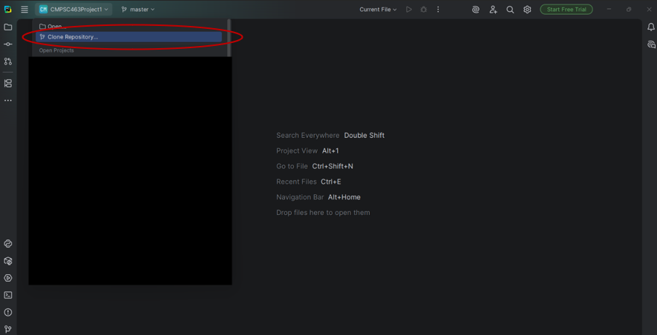

Step 2:
Copy and paste the git URL (https://github.com/AramAsdourian/CMPSC463Project1) and press ‘clone’.
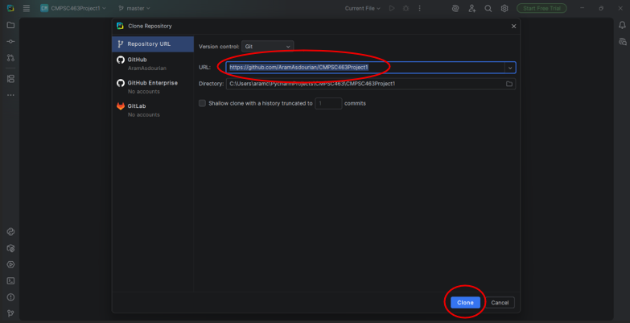

Step 3:
Run the code and view the results
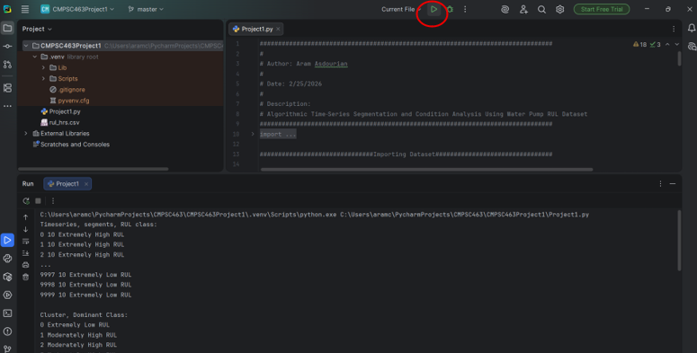
Enter a input to view more detailed data or exit the program:

Code Structure Explantation
The structure of the code is split into 4 sections, The importing of the dataset, task 1 (segmentation), task 2 (clustering), and task 3 (max subset).

The importing of the dataset imports the csv dataset and interprets the data into a readable form using dictionaries. It then assigns class values based on the RUL quintiles.

The segmentation section implements the segmentation algorithm and then calls it on each timeseries in the dataset, it adds the segment complexity score to a dictionary and prints that data for the user.

The clustering section implements the clustering algorithm and then calls it on the segment complexity returned by the segmentation algorithm. The clusters returned by the algorithm are then ran through a for loop to calculate the dominant class of each cluster. The information is then printed for the user

Finally the max subset section implements the max subset (Kadanes) algorithm and calls it on each sensor in the dataset. It then uses the same technique from the clustering section to find the dominant class of each max subset. The information is then printed for the user.

Algorithm Description

Segmentation
The segmentation algorithm is a recursive algorithm that accepts one list of data as parameter. First it computes mean by summing the total and dividing by length. Then it finds deviance by subtracting mean from each value. Next it computes the variance by dividing the sum of deviations by length. The data is then recursively broken in half if the variance is deemed unstable (if variance is above a chosen threshold). Otherwise, it returns 1 which is added up to return the total amount of segments

Clustering
The clustering algorithm is a recursive algorithm that accepts a list of data and the number of returned clusters as parameters. First it checks the base case if the number of clusters has been reached and returns the clusters. Otherwise it finds the min and max of the current list of data to find the centers for the next 2 clusters, then it iterates over each piece of data and adds them to the cluster it is closest to. The 2 clusters are then each recursively called into the clustering algorithm and returned. The result is a dictionary containing lists of each returned cluster.

Max subset
The max subset (kadanes) algorithm is an iterative algorithm that accepts a list of data as a parameter. First it preprocesses the data by finding the absolute first difference. To do this it finds the difference of each value compared to the previous value, then finds the variance of the differences using the same method from the segmentation algorithm. From there it iterates over each value in the variance and decides each loop if it would be more optimal to extend the max subset or keep it the same. Finally, it returns the start and endpoint of the max subset.

Toy Example Description
Testing on only the first 10 timeseries:

Segmentation: Max subset:
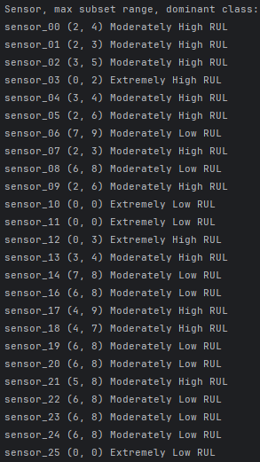
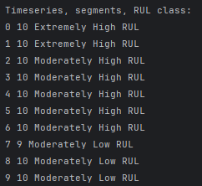

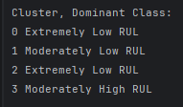
Clustering:

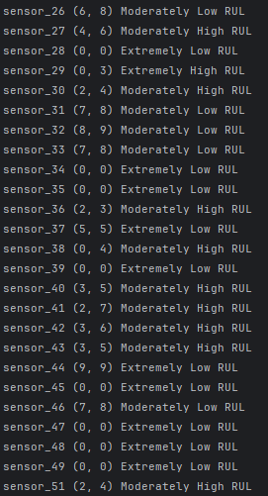

Dataset Description
I chose to convert the dataset into a csv file and import it using pythons built-in open() function. I imported the file and interpreted the data into a dictionary called ‘dataset’. This dictionary held 2 dictionaries called ‘row’ and ‘column’. The ‘row’ dcitionary stores all the information row-wise, in the context of this dataset each row represents the data returned by each sensors over time. The First 2 columns of this dataset are the timeseries and timestamp, the next 51 represent data returned by one of the 51 sensors, the last column represents the RUL (Remaining useful life in hours). To interpret this data further I added a new column at the end that splits the RUL into quintiles labeled “Extremely Low RUL”, “Moderately Low RUL”, “Moderately High RUL”, and “Extremely High RUL”.

Execution Results

Task 1:
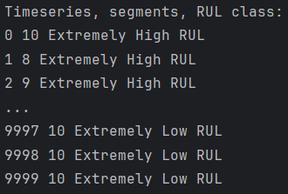

Task 2:
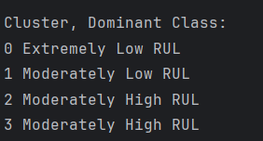

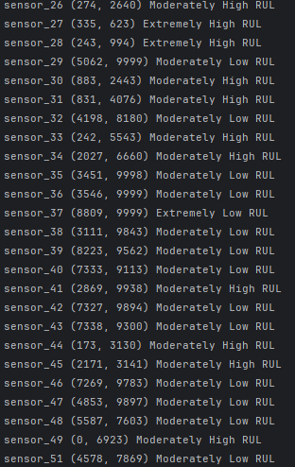
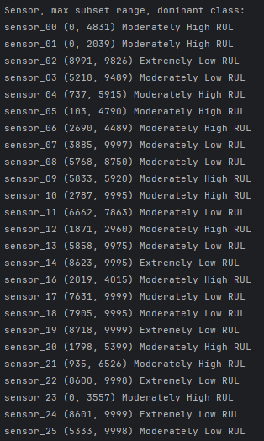
Task 3:

Discussion and Conclusions
My findings from this project are that the segmentation algorithm can tend to be unpredictable due to only using data from 10 sensors. The clustering algorithm is slightly more consistent with each cluster consistently falling into the same 1 or 2 classes. The max subset algorithm is the most reliable by showing data on each individual sensor which combats skewing from one sensor having outlier data. The main challenge with implementing these algorithms was trying to figure out how to develop them on my own since we did not go over them in class. This leads to the biggest limitation which is my inexperience with these algorithms means I have no reliable reference for if I implemented them correctly, future improvements mainly lay in me progressing my education and learning more about algorithm development.

